**Number of irregular crossings at Europe’s borders at lowest level in 5 years**

2019-01-04

Last year the number of illegal border-crossings at Europe’s external borders has fallen by a quarter compared with 2017 to an estimated 150 000, the lowest level in five years. The total for 2018 was also 92% below the peak of the migratory crisis in 2015.

The drop was due to the dramatic fall in the number of migrants taking the Central Mediterranean route to Italy. The number of detections of irregular crossings on this route plunged 80% compared to 2017 to slightly more than 23 000.

The Central Mediterranean route saw the smallest number of irregular entries since 2012. The number of departures from Libya dropped 87% from a year ago, and those from Algeria fell by nearly a half. Departures from Tunisia stayed roughly unchanged. Tunisians and Eritreans were the two most represented nationalities on this route, together accounting for a third of all migrants.

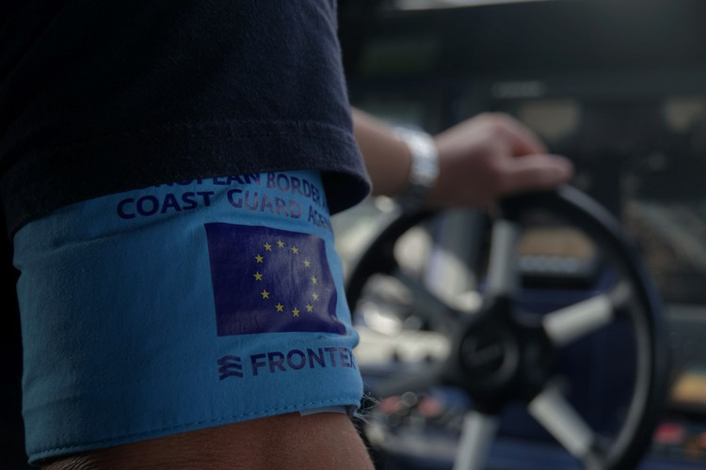

Meanwhile, the number of arrivals in Spain via the Western Mediterranean route doubled last year for the second year in a row to 57 000, making it the most active migratory route into Europe for the first time since Frontex began collecting data.

On the Western Mediterranean route, Morocco has become the main departure point to Europe. Most of the migrants on this route originated from sub-Saharan countries, although in recent months the number of Moroccan migrants has increased to become the top reported nationality. They were trailed by Guineans, Malians and Algerians.

The number of detections of illegal border-crossings on the Eastern Mediterranean route rose by nearly a third to 56 000. This was mainly caused by a higher number of migrants crossing the land border between Turkey and Greece, while the total number of detections in the Eastern Aegean Sea was roughly in line with 2017. Nevertheless, the number of arrivals registered in Cyprus more than doubled. Nationals of Afghanistan, Syria and Iraq accounted for the largest number of irregular migrants on the sea route in the Eastern Mediterranean, while Turkish nationals were the main nationality on the Turkish-Greek land border.

Last year, Frontex for the first time began to collect detailed data on the gender and the age of irregular migrants. These showed that women accounted for 18% of all illegal border-crossings on entry from third countries. Nearly one in five of the detected migrants claimed to be under the age of 18, with close to 4 000 unaccompanied minors reported on entry at the EU external borders in 2018.

*Note: The data presented in this statement is preliminary and refer to the number of detections of illegal border-crossing at the external borders of the European Union. The same person may attempt to cross the border several times in different locations at the external border.*